EXP:4
Implement a C Program for Given an array finding duplication values
AIM:
Identify and print duplicate elements present in an integer array.
ALGORITHM:
- Read size and array elements.
- For each element compare with following elements.
- If duplicate found and not already printed, print it.
- Continue until array processed.
PROGRAM:
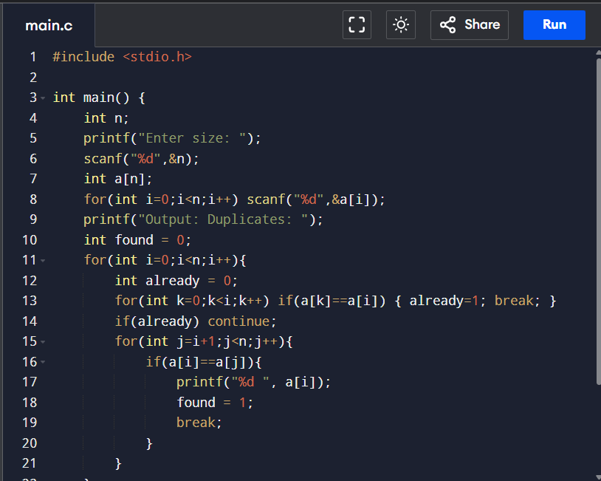
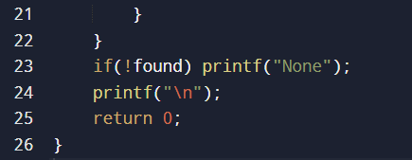
OUTPUT:
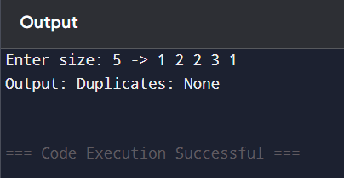
RESULT:
Program prints duplicate values or None.

